ACLRS — Patient Portal Module Test

Patient Portal
Tester | KIM NGAN LE
Date | 25/09/2026
Module | Patient Portal
Testing Tool | Selenium WebDriver
Web Browser | Google

Test Case Summary
Test ID | Tool | Test Result | Comment
TC-PAT-01 | Selenium WebDriver | PASS
TC-PAT-02 | Selenium WebDriver | PASS
TC-PAT-03 | Selenium WebDriver | PASS
TC-PAT-04 | Selenium WebDriver | PASS
TC-PAT-05 | Selenium WebDriver | PASS
TC-PAT-06 | Selenium WebDriver | PASS
TC-PAT-07 | Selenium WebDriver | PASS
TC-PAT-08 | Selenium WebDriver | PASS
TC-PAT-09 | Selenium WebDriver | PASS
TC-PAT-10 | Selenium WebDriver | PASS
TC-PAT-11 | Selenium WebDriver | PASS
TC-PAT-12 | Selenium WebDriver | PASS
TC-PAT-13 | Selenium WebDriver | PASS
TC-PAT-14 | Selenium WebDriver | PASS | Initial test failed because the automated form submission remained on the AI Health Insights page instead of navigating to the Meal Recommendation result. The Selenium test was modified to submit the Meal Recommendation form directly, the re-test passed.
TC-PAT-15 | Selenium WebDriver | PASS
TC-PAT-16 | Selenium WebDriver | PASS | Initial test failed with ElementClickInterceptedException when Selenium attempted to click the Explain This Result control. The Selenium interaction was modified to avoid the intercepted browser click, and the re-test passed.
TC-PAT-17 | Selenium WebDriver | PASS | Initial test failed because the automated form submission remained on the AI Health Insights page instead of navigating to the Result Progression form directly, and the re-test passed.
TC-PAT-18 | Selenium WebDriver | PASS | The initial test did not successfully verify the complete logout and session termination process. The logout test was revised to verify login redirection and confirm that the protected dashboard could not be accessed after logout. The re-test passed.

Evidences:
- TC-PAT-01
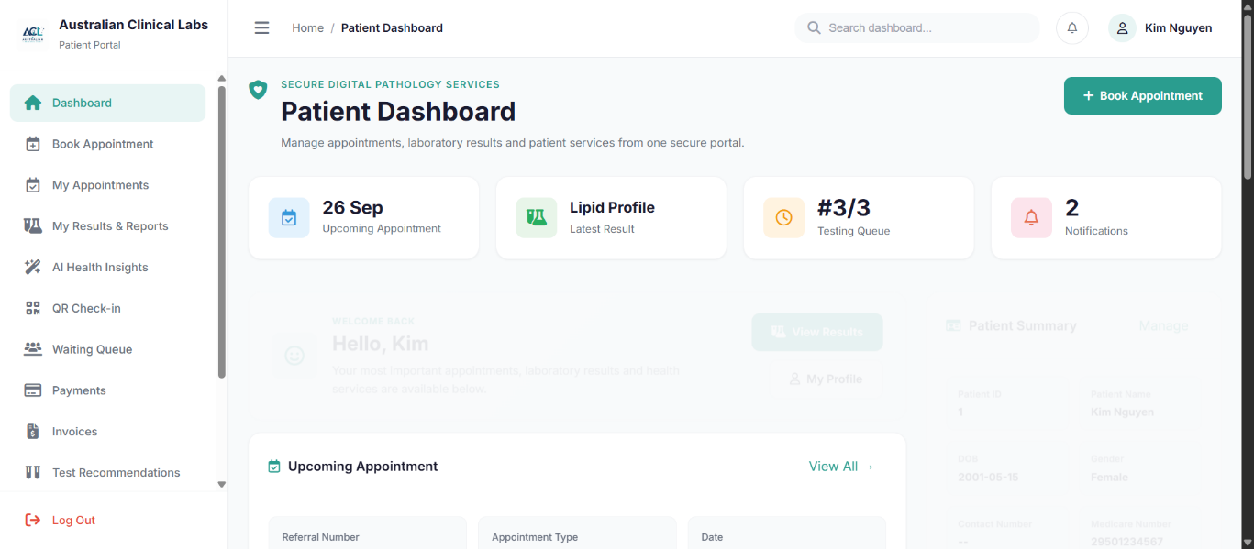
- TC-PAT-02
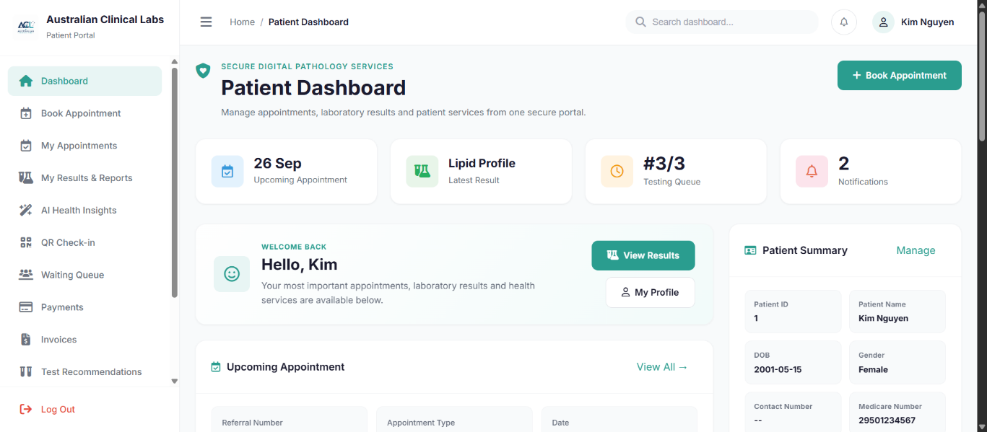
- TC-PAT-03
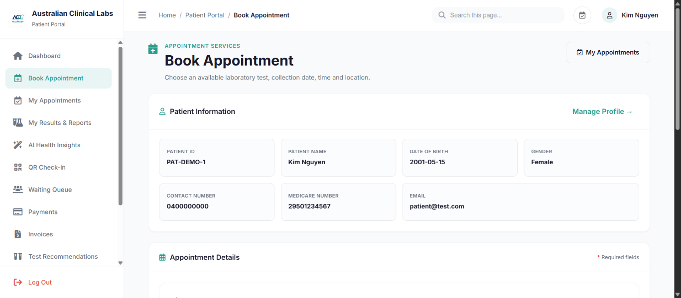
- TC-PAT-04
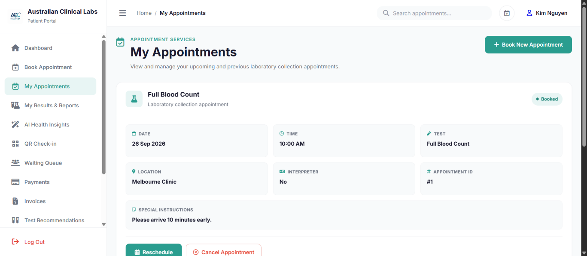
- TC-PAT-05
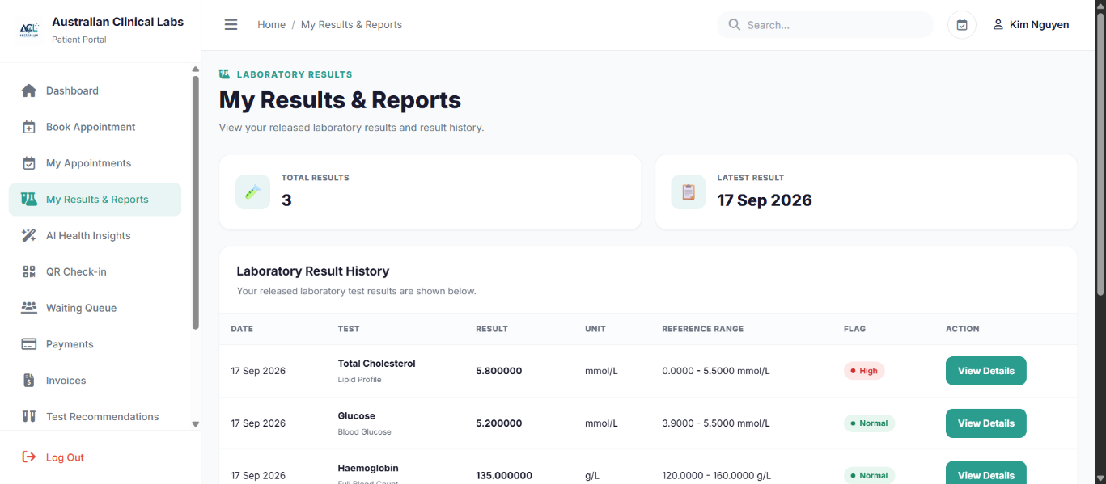
- TC-PAT-06
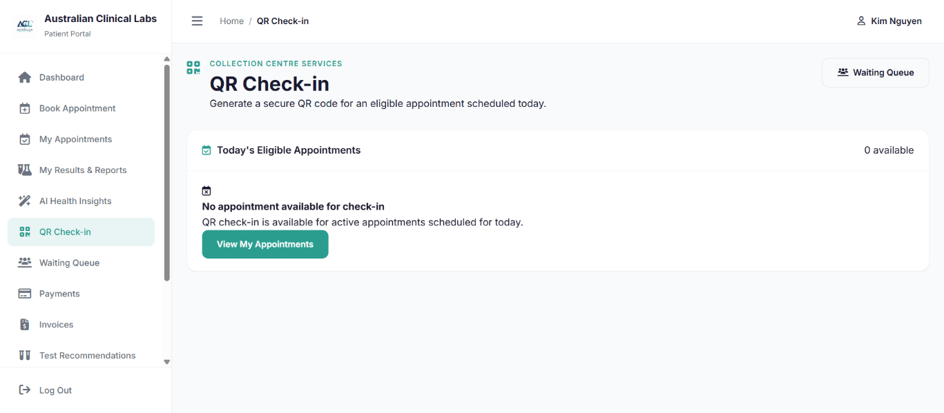
- TC-PAT-07
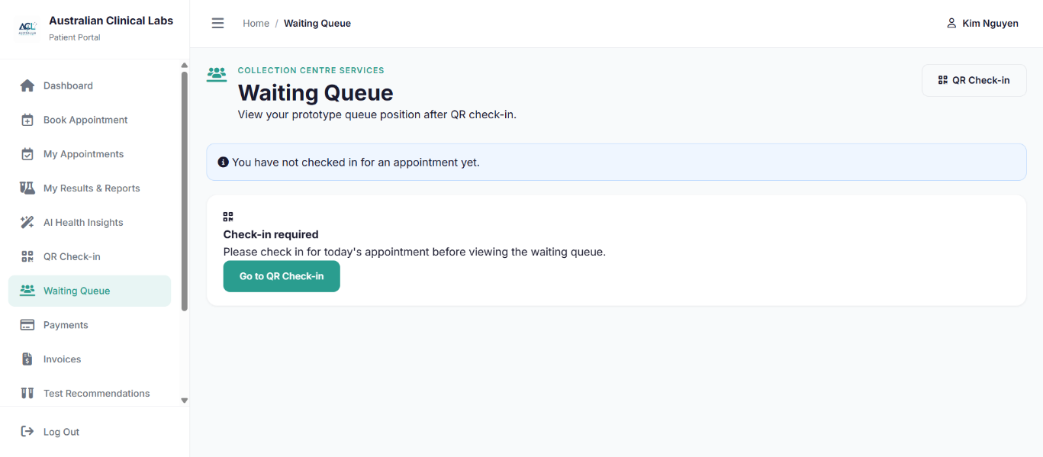
- TC-PAT-08
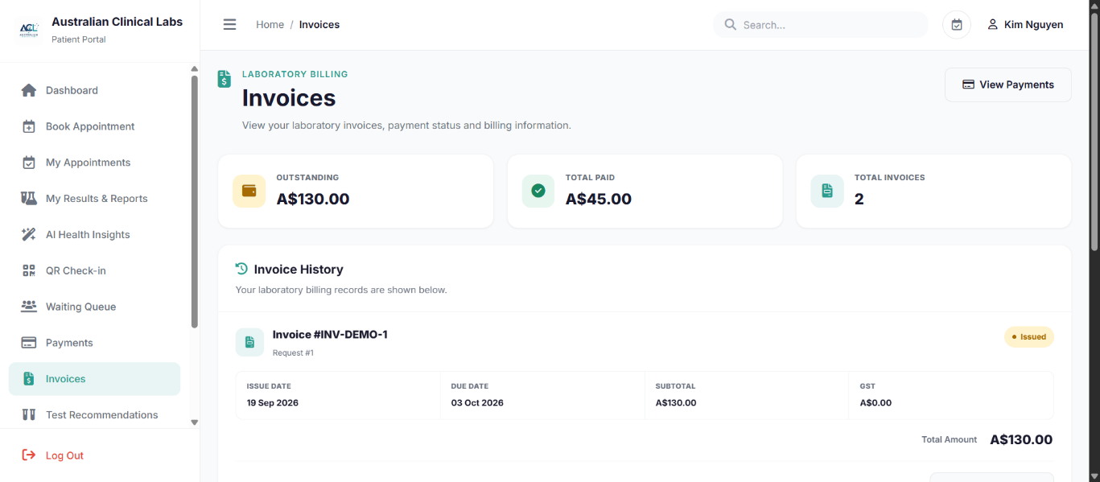
- TC-PAT-09
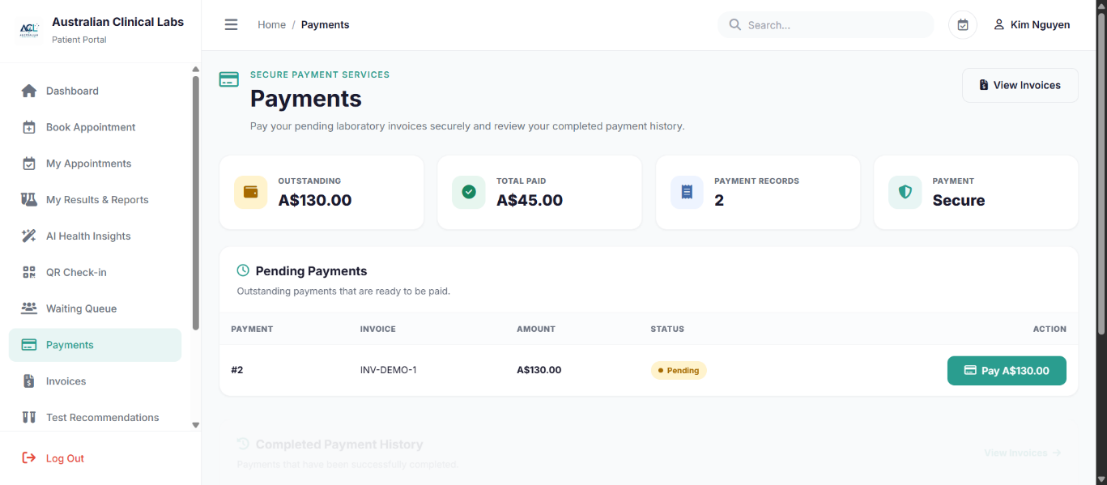
- TC-PAT-10
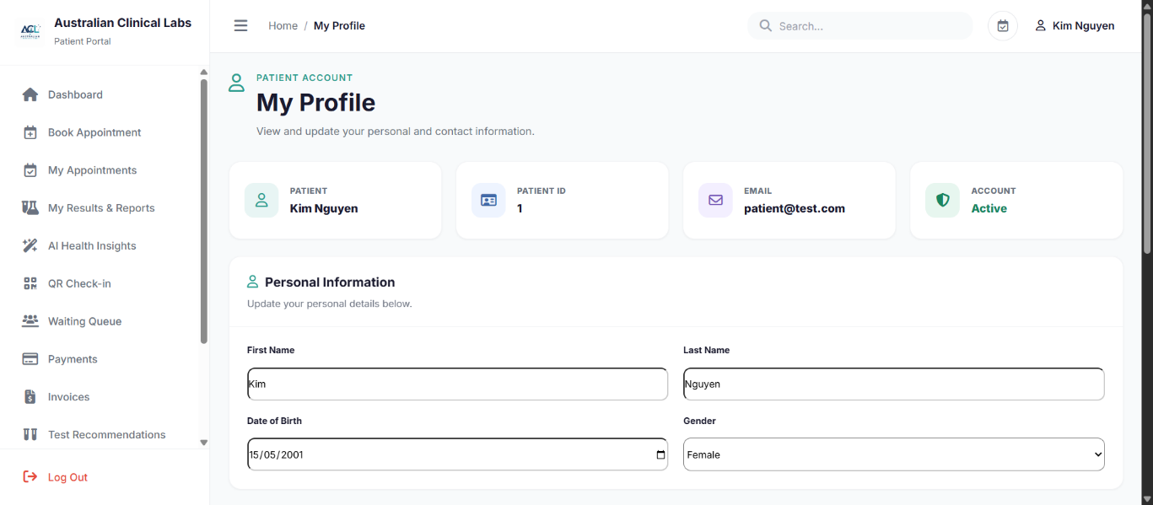
- TC-PAT-11
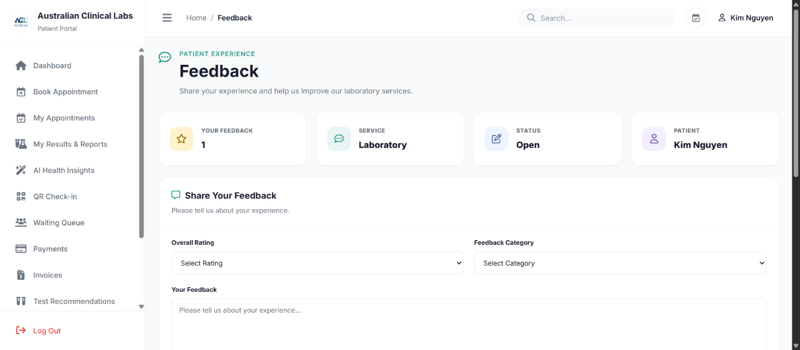
- TC-PAT-12
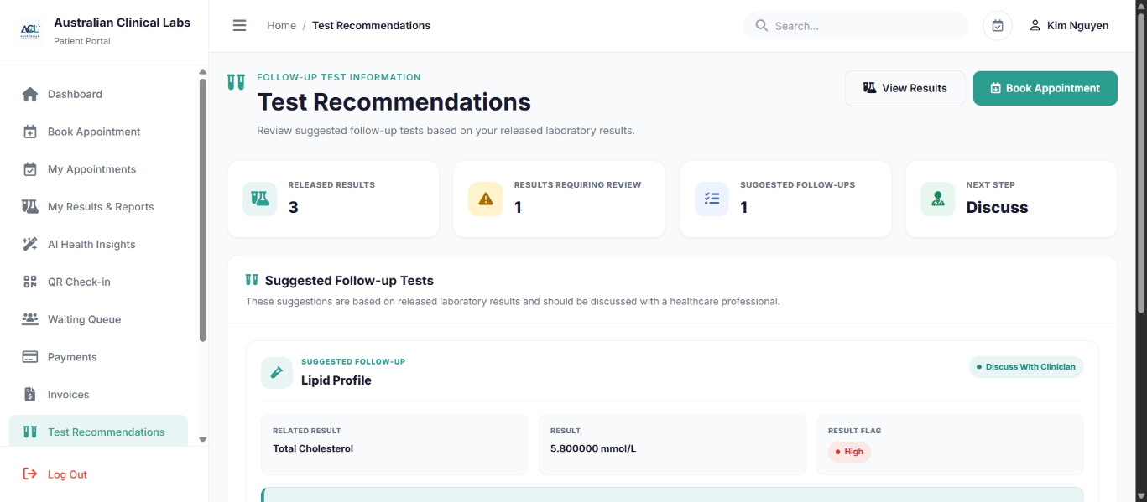
- TC-PAT-13
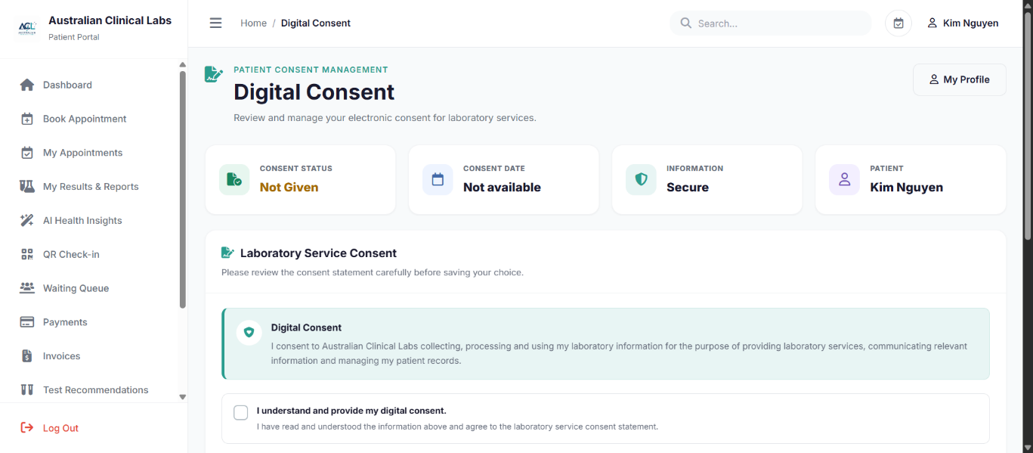
- TC-PAT-14 – Fail
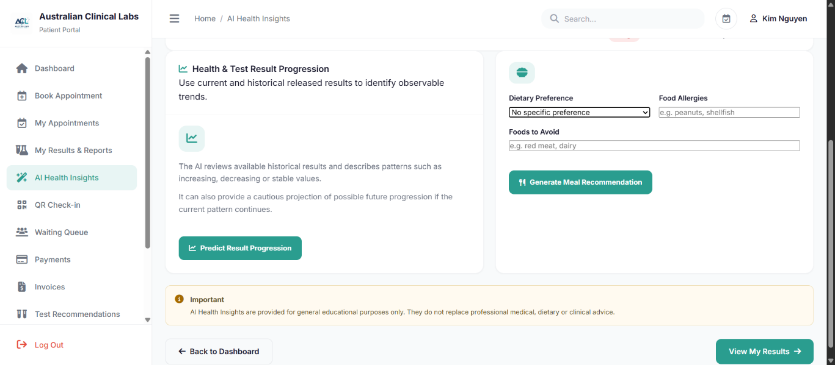
- TC-PAT-14 – Pass
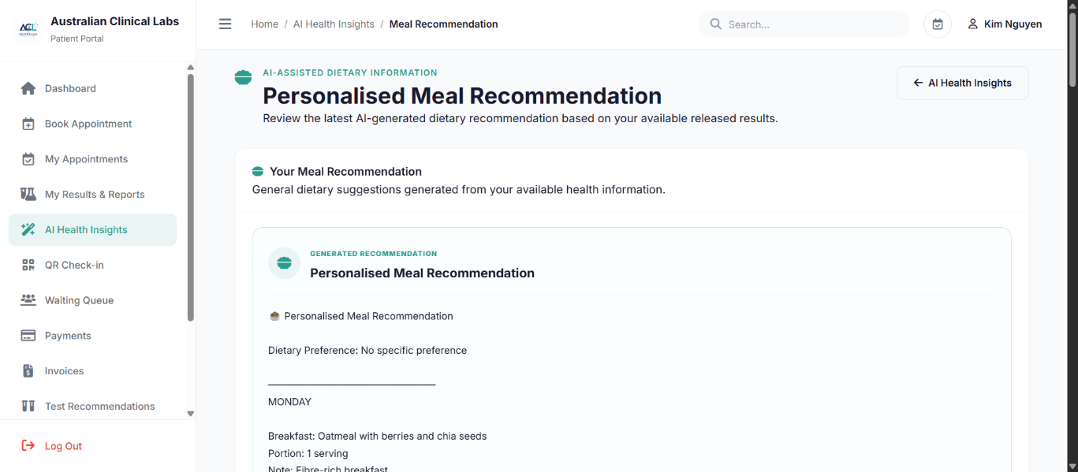
- TC-PAT-15
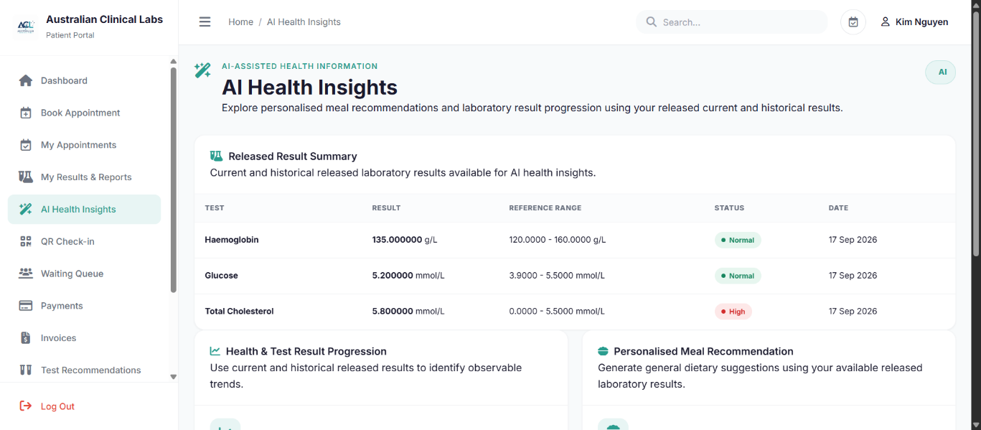
- TC-PAT-16 – Fail
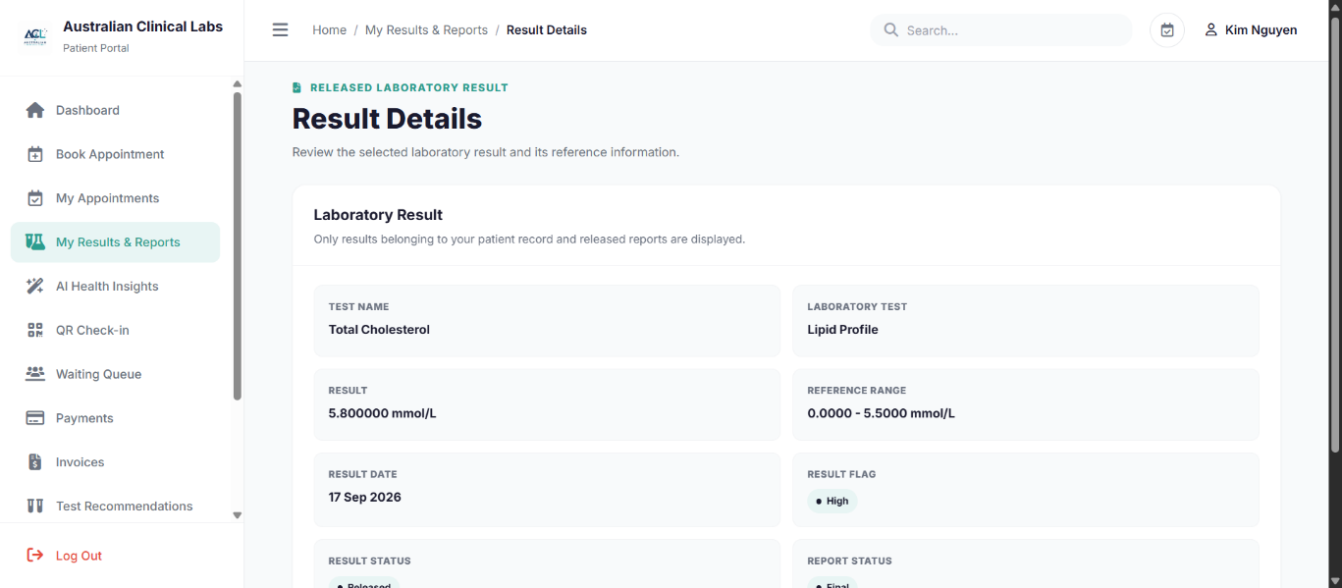
- TC-PAT-16 – Pass
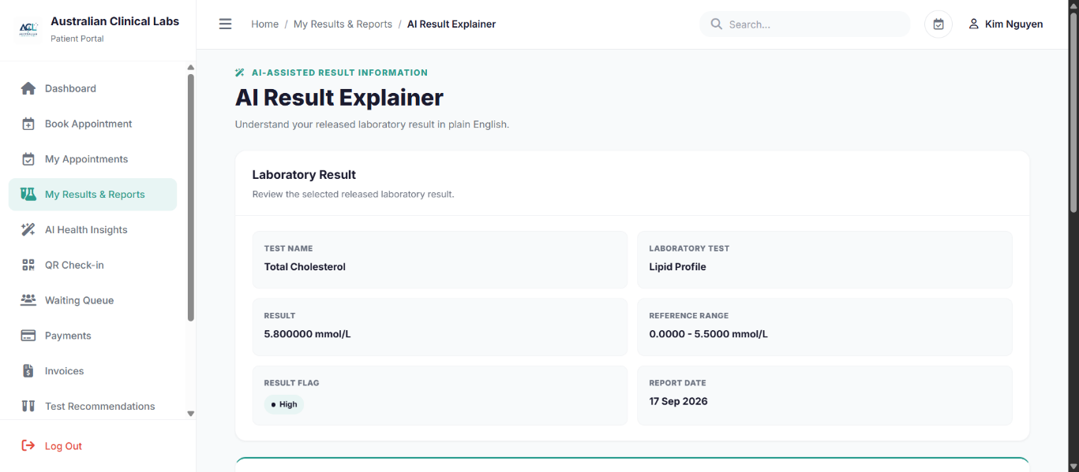
- TC-PAT-17 – Fail
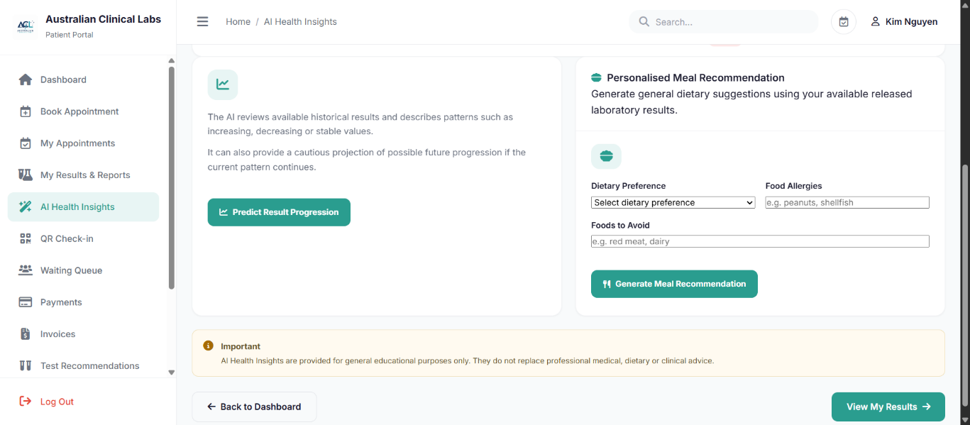
- TC-PAT-17 – Pass
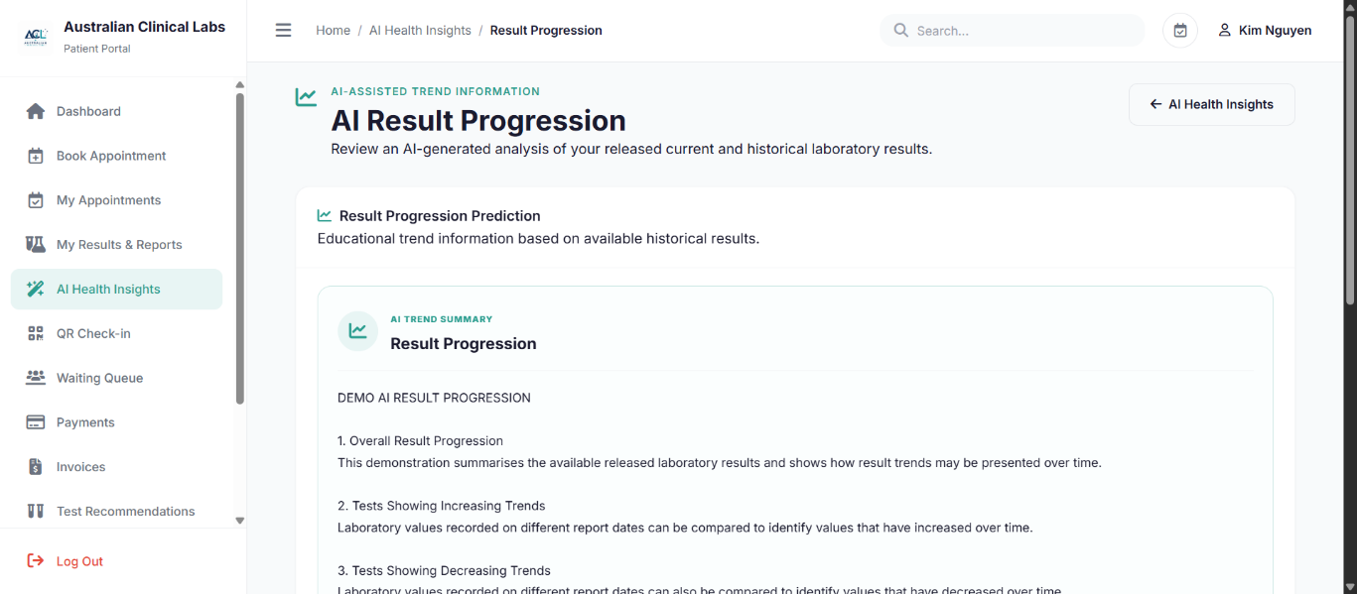
- TC-PAT-18 – Fail
- TC-PAT-18 – Pass


